
Department of CSE

B.Tech. CSE Trimester -5

Roll Number-2520030154
Name- Pothuru Bhavana Manaswini

Cloud Infrastructure and Services
25CS2206E

LAB RECORD
2026

Experiment -1

AIM: To create an AWS free tier account to provision the resources.

Description:
To create an AWS account, complete the required verification procedures, and successfully access the AWS Management Console.
To have in beforehand:
- Valid email ID.
- Mobile phone number for OTP verification.
- Personal details (name and address).
- Internet connection.
- Payment method, requested by AWS:
  - Credit/Debit Card
  - UPI
- AADHAR, PAN or another accepted identity document, if requested during AWS India customer verification.

Steps:
- Open “https://aws.amazon.com/free” and sign in to console
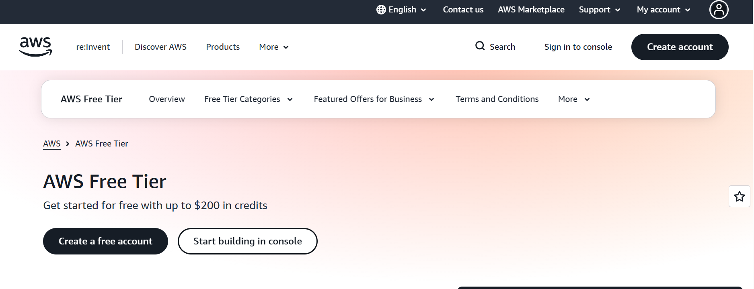

- Create new AWS account
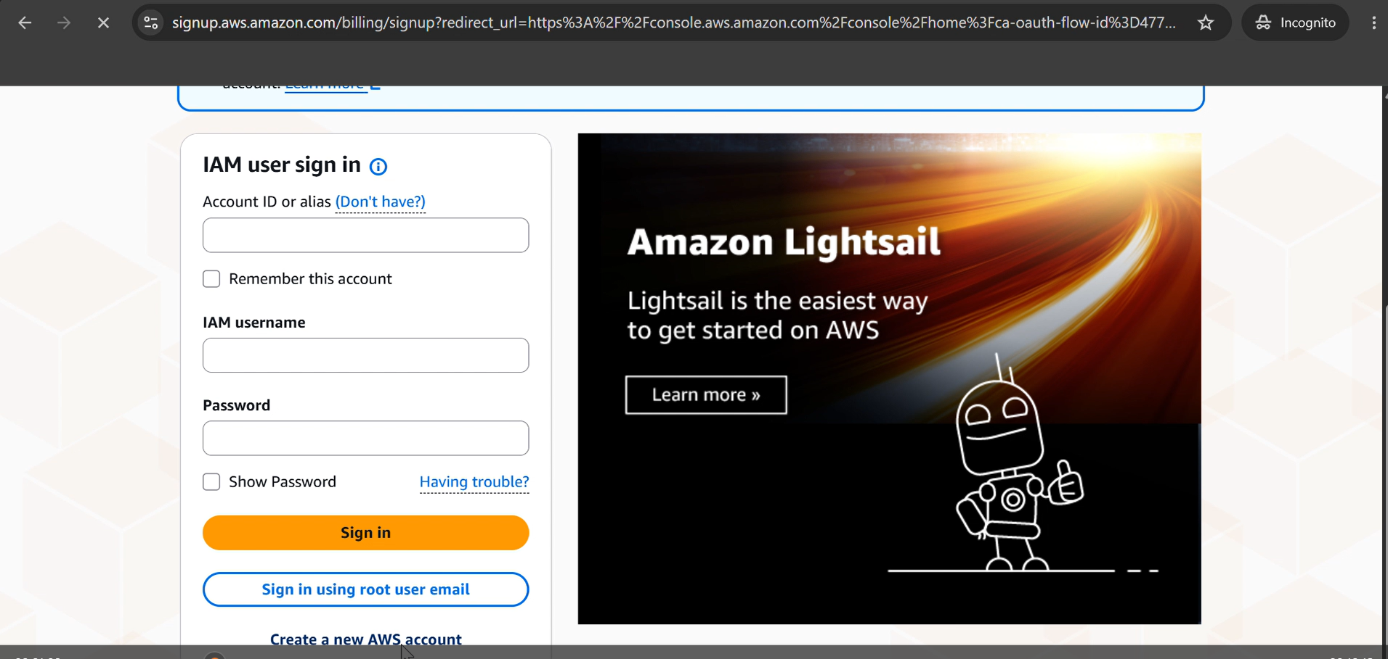

- Enter details and click on verify

- Enter OTP sent to the email address

- Choose free plan
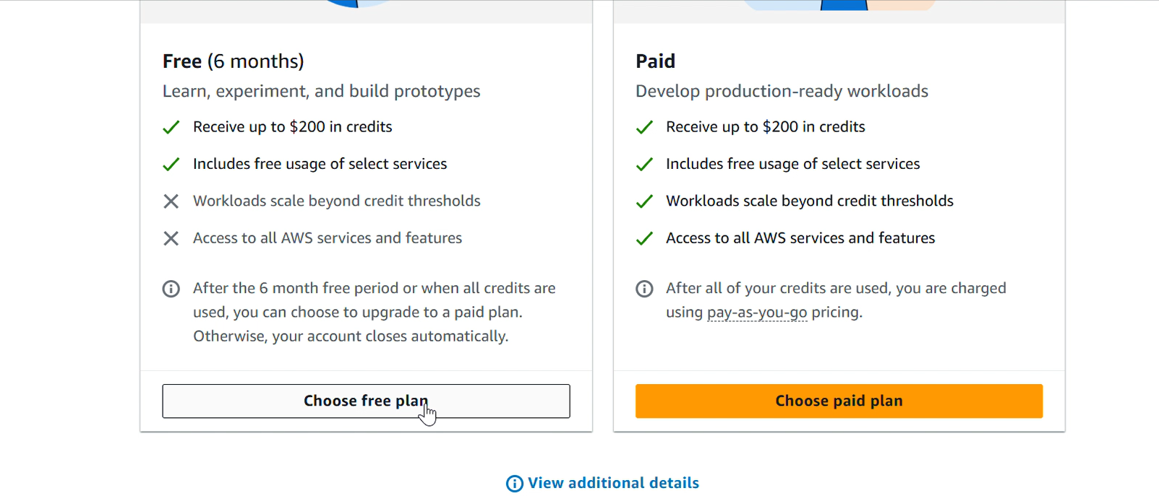

- Give contact and personal Information- full name, phone number, address etc

- Provide Billing Information- choose UPI and give details, we can delete the autopay later

- ₹2 will be charged, which will be refunded after verification

- Confirm identity = Academic, Individual

- Document type as AADHAR – verification will be done by digiLocker.

- Link the AWS account with digilocker.

- Give mobile number and enter the verification code sent to sms and click continue.

- You will see AWS Console dashboard
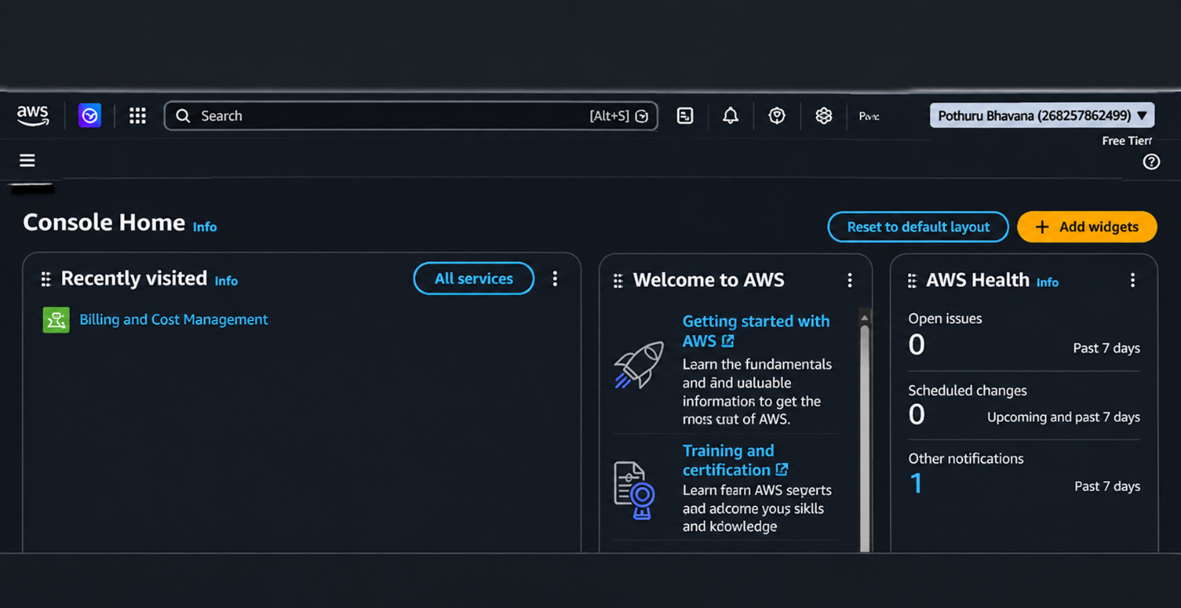

Output:
A new AWS account is successfully created, verified and accessed through the AWS Management Console.


